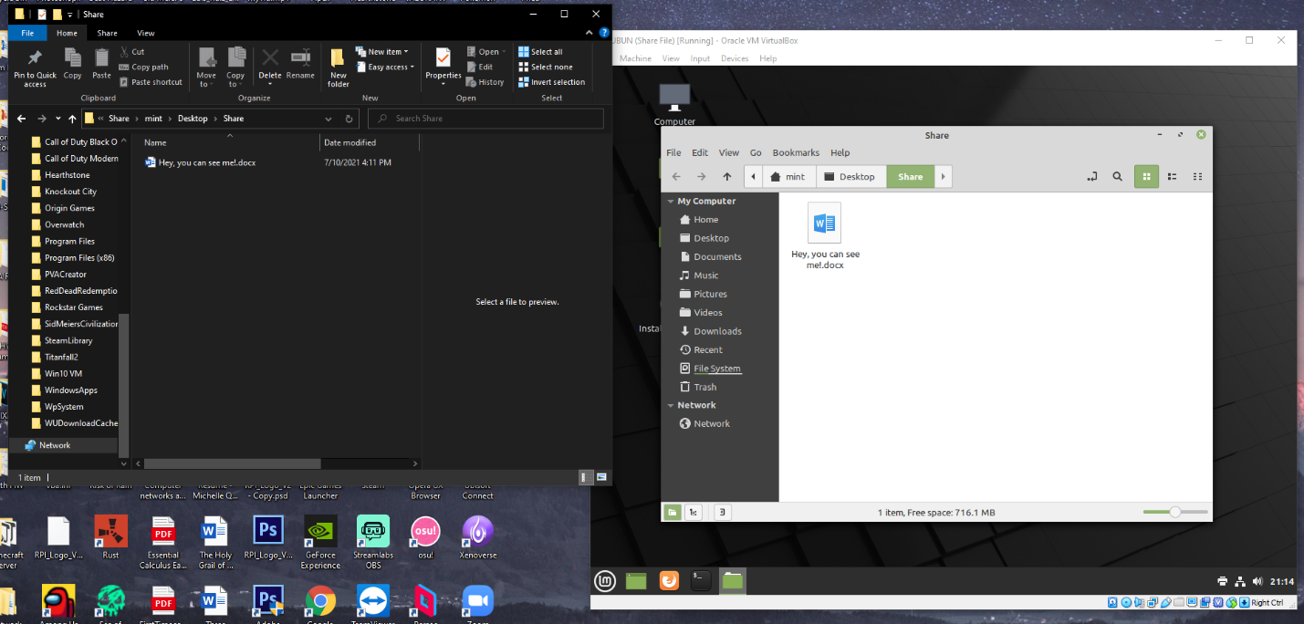

Created a Samba user which I then started a share folder on my Linux environment. This will allow the Window to be able to search for it by just putting the IPV4 address that can be provided when searched up. Once placed into the folder it will establish a connection which will allow me to send folders and have access to majority of the files on the computer not just a folder.

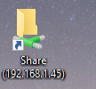

The folder when the IP was connected.

